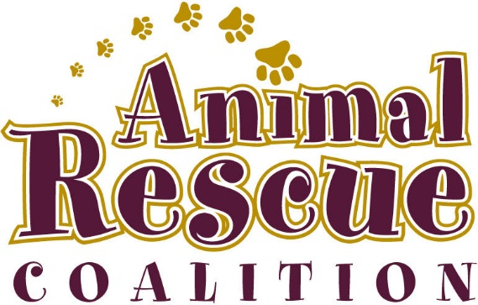

SURRENDER AGREEMENT

I, the undersigned, have made the decision to surrender the following named pet and have chosen to enlist the adoption services of Animal Rescue Coalition (ARC), who will place then in a new home as appropriate.

Animal Name
Cat/Dog/Other | ◻Dog ◻Cat ◻Other (specify)
Male/Female | ◻Male ◻Female
Spayed/Neutered | ◻Yes ◻No
Breed

Identifying Marks (if any)

Weight

Approximate Age

Behavior Issues

Health Issues

Reason for surrender

- I understand that by surrendering the above pet to Animal Rescue Coalition (ARC) means that all of my involvement and rights, regarding this pet, from this date forward are null and void.
- I have disclosed all information regarding the heath, temperament, and behavior of this pet to ARC truthfully and to the best of my knowledge.

- ARC assumes full ownership including responsibility for any illnesses and will provide appropriate veterinary care for the surrendered animal while in their custody. Upon adoption of this pet in a new home all Veterinary care responsibilities will be transferred to the new owner.

- ARC agrees to make every reasonable and responsible effort to rehome this pet. Each animal will be assessed and dealt with on an individual basis involving appropriate parties.

- No animal will be knowingly placed in a home or institution for the purpose of ritual, rite, contest, display or medical experimentation.

- ARC guarantees to the surrendering party that the animal will receive utmost in care and consideration in the placement with a new owner and that future contact with the new owner will be done in the interest of continued health and welfare concerns. ARC operates as a service to animals and as such is not a business.

I have read, understand and agree to all of the above.

Signed this ________ day of __________________________, 20________

Owner Name (Print) |  | Owner Signature
Co-Owner Name (Print) |  | Co-Owner Signature
Animal Rescue Coalition Member  (Print) |  | Animal Rescue Coalition Member Signature

Owner Address:
Phone #:
Email Adress:
One copy to the Owner and one copy to ARC

