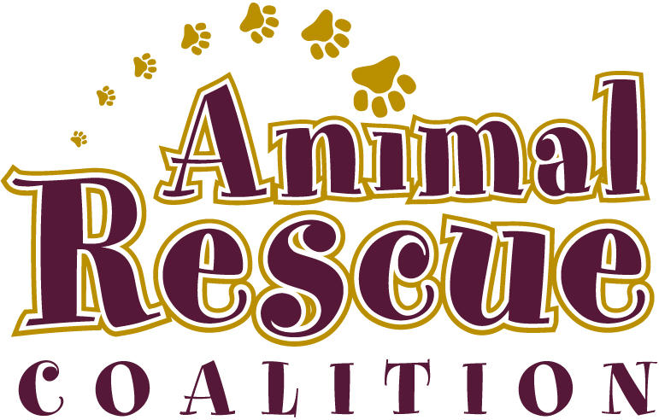

ANIMAL RESCUE COALITIONS NOVA SCOTIA SOCIETY
FOSTER APPLICATION

Date:

Full Name:

Name of Employer:

Full Name of Spouse:

Name of Spouses Employer:

Complete Mailing Address:

Email Address:

Phone: (Home)
(Work)
(Cell)

Please provide 2 personal references that we may contact:

1. Name:
Relationship:
Phone:

2. Name
Relationship:
Phone:

Please provide a veterinary reference that we may contact- (Please phone vet and give permission for them to speak with us in regards to your pets health records)

Name:
Phone:

Preferred age of dog: Any age_______ Up to 5 Yrs_______ 5 Yrs and Older________

Preferred Gender: No preference_________ Male_______ Female_______

Other Preferences_______________________________________________________

Please answer the questions on the following pages as completely as possible.

1. Why do you want to become a foster?

2. What do you think are the most important responsibilities in fostering?

3. Do you have experience with a particular breed of dog?

4. Do you understand and accept that changing an animal’s environment may cause the animal to have accidents, especially in the first few days of being in your home?

5. Are you aware that a foster animal may, at some point, destroy or break something of yours?

6. Does any member of your family have any allergies to animals?
If yes, please explain:

7. Have you ever owned a pet before?

8. If yes, what kind of animals and when?

9. Are your current pets spayed/ neutered and up to date on their annual vaccines?

10. If not spayed/ neutered and up to date on vaccinations please explain why?

11. Which pets do you no longer own?

12. What happened to them?

13. How many people currently live in your household?

14. Are there children in your household and if so what are their ages?

15. Do they have experience handling animals?

16. Do children frequently visit your home?

17. Have you considered if the children in your home know how to properly interact with a new animal?

18. How would you describe the activity level in your home (loud, quiet, calm)?

19. Are you prepared to meet the exercise and activity needs of dog?

20. If, for any reason, you are unable to continue fostering your animal, do you agree to notify ARC immediately and without hesitation?

21. Do you own a vehicle?

22. What type of dwelling do you live in and do you rent or own (i.e. a condo, apt, single family home, Condominium, etc)?

23. If you rent, does your landlord allow you to have pets? (Please provide a written letter of permission from your landlord)

24. Do you have a fenced yard?

25. Describe the fencing (height, materials, any holes or gaps)?

26. How will you be letting the dog outside if there is no fence?

27. Would you walk the dog on leash or off leash?

28. Where will the dog be kept during the day?

29. How many hours will the dog be left home alone?

30. Where will the dog be kept at night?

31. Where will the dog sleep?

32. Have you ever been convicted of or investigated in relation to animal abuse, neglect or fined under either the Provincial Dog Act, its Regulations or Municipal Animal Control By-laws?

33. Have you ever fostered for another organization in the pas? If yes, which organization and when?

34. Have you had a foster application turned down by an animal placement organization? If yes, please explain.

35. Please list any final questions here.

By signing this foster application I:

- Am at least 19 years of age
- Am willing and able to care for a dog placed in my care
- Will provide a safe and stable indoor home for the dog
- Understand that all animals placed in my care are sole property of Animal Rescue Coalitions and am not permitted to assume ownership without signing an adoption contract, destroy, give away, breed, or sell any animal that has been placed in my care for foster purposes and will never cause harm or injury to a foster pet.
- Understand that Animal Rescue Coalitions is not responsible for any damages that an dog may cause to my property and make no guarantee of house training or temperament regarding the animal
- Understand that Animal Rescue Coalitions will provide all necessary supplies for basic care (food, dishes, leash, etc.) and pay for all vet costs.

Dated this_______________day of______________, 20_____

Applicant’s Name (Print)______________________________

Applicant’s Signiture_________________________________

Criteria for Adopting a current Foster Animal:

- Current pets must be spayed/neutered and up to date on all vaccinations unless medical reasons prohibit.

